Youtube Video Link:

[Stdout.Systems - Meta Merge Tasker Project Presentation](https://youtu.be/BXRPnb8UcEI)

[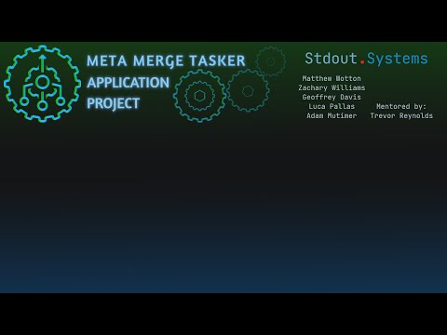](https://youtu.be/BXRPnb8UcEI)